**ASSIGNMNET 3**

***Q1. What are the primitive data types in C Language?***

*Primitive is the most fundamental data type usable in the Programming language. There are eight primitive data types:***Boolean, byte, character, short, int, long, float,***and***double.***In a Programming language, these data types serve as the foundation for data manipulation.*

***Q2. What kind of statements can be written outside the function body?***

|  |
| --- |
|  |
|  |
| *Mostly Declaration statement written outside the function.* |
|  |
|  |
|  |

***Q3. What is the size of float type variable?***

*The size of float type variable is 4 byte in both 32-bit size and 64-bit size compiler.*

***Q4. What is the value of an uninitialized variable?***

*An uninitialized variable has an****undefined value.*** *When a variable is assigned a memory location by the compiler, the default value of that variable is considered as any garbage value.*

***Q5. What is the difference between float and double?***

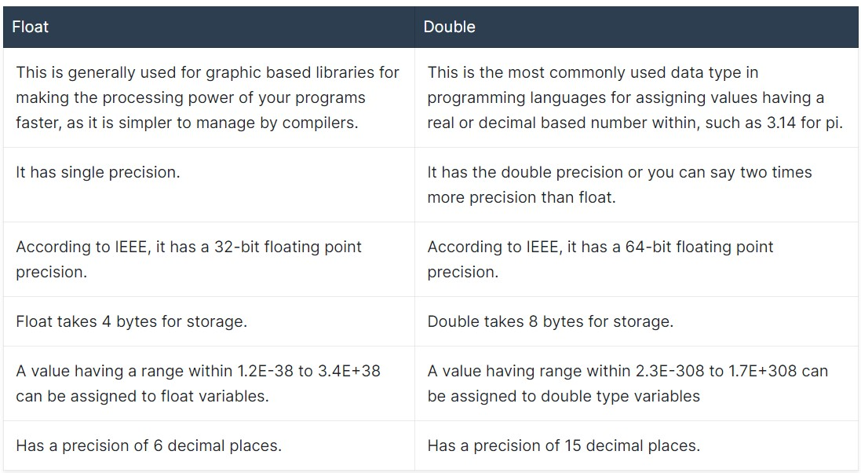

***Q6. What is the full form of ASCII?***

*The full form of ASCII is American Standard Code for Information Interchange. It is the most common character encoding format for text data in computers and on the internet.*

***Q7. What is the difference between a keyword and a function?***

*Keywords in C Programming Language:*

*Keywords are those words whose meaning is already defined by Compiler*

*Cannot be used as Variable Name*

*There are 32 Keywords in C*

*C Keywords are also called as Reserved words.*

*Functions In C Programming:*

*C functions are basic building blocks in a program. All C programs are written using functions to improve re-usability, understandability and to keep track on them.*

***Q8. Explore the use of type modifiers in C language.***

*Modifiers are keywords in C which changes the meaning of basic data type in c. It specifies the amount of memory space to be allocated for a variable. Modifiers are prefixed with basic data types to modify the memory allocated for a variable.*

*There are two types of type modifiers:*

* *Size modifiers - short, long*
* *Sign modifiers - signed, unsigned*

*The modifiers signed and unsigned can be applied to char and integer types. When the modifiers unsigned is used the number is always positive, and when signed is used number may be positive or negative.*

***Q9. Can you assign a character constant in an int variable?***

*Yes, we can assign a character constant in an int variable. In C, character constant is of type int.*

*e.g., int a='a'*

***Q10. State the following statement as true or false -” Every block of code is a function”.***

*False, Every block of code is not a function.*

*e.g., Block of for loop in C programming is not a function.*